

**Chat Bot**

**Name**: Maheen Sadaf

**Section**: A2

**Course**: Programing for AI

**Resource Person**: Mehmood Hussain

**Bruno Bot**

In my **Bruno bot** I implemented several techinques inorder to make my **BOT** more efficient.

The steps I followed in building my **BrunoBot** are:

* **LogIn Module (Sign in/ Sign Up)**

First of all i made a login/signup module for my chatbot using **FLASK** because Flask is a popular Python web framework used for developing web applications. It provides a simple and flexible framework for building web applications. Its lightweight design and extensive ecosystem make it an ideal choice for developers seeking customization and efficiency.

* **Small Talk/ Casual Conversation**

Then I setup my Bruno Bot using the Aiml files so that It might be able for a small talk and casual Conversation

* **NLP**

Then I applied NLP in my chat Bot because Natural Language Processing (NLP) enable them to understand and generate human-like responses. NLP allows chat bots to process and analyze natural language input, extract meaning from it, and generate relevant and contextually appropriate responses. It helps in enhancing the user experience by making the interaction with the chat bot more conversational and intuitive.

I use the some functions of NLP in my Chat Bot like:

* **Spell Checking**

Spell checking is a process in Natural Language Processing (NLP) that involves identifying and correcting spelling errors in text. It is a crucial component in many applications, including word processors, search engines, and chatbots.

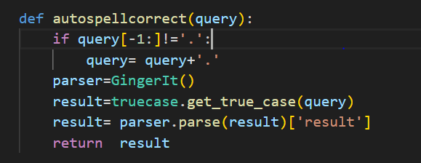

* **Word token,** **Sent token** ,**POS ,** **NER**
* **Word Tokenization:**

Word tokenization is the process of splitting a text or sentence into individual words or tokens.

* **Sentence Tokenization**:

Sentence tokenization refers to splitting a paragraph or a larger piece of text into individual sentences.

* **Part-of-Speech (POS) Tagging**: POS tagging is the process of assigning grammatical labels or tags to each word in a sentence, based on its part of speech (e.g., noun, verb, adjective, etc.).
* **Named Entity Recognition (NER):** NER is a task in NLP that involves identifying and classifying named entities in text, such as names of persons, organizations, locations, dates, etc.

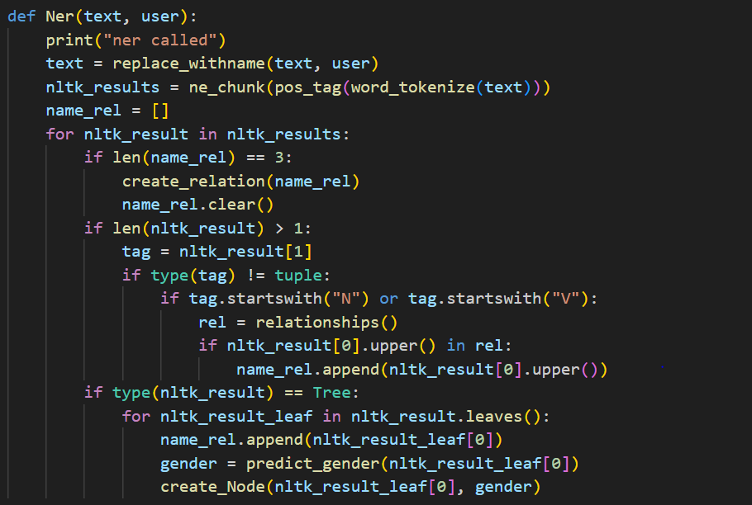

* **Sentiment Analysis**

Semantic analysis, also known as sentiment analysis or opinion mining, is a branch of Natural Language Processing (NLP) that focuses on understanding and extracting meaning from text based on the sentiments or opinions expressed.

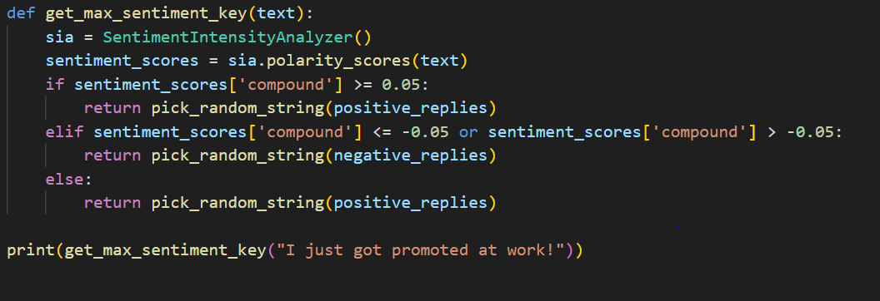

* **Machine Learning**

Then I implemented the **ML** to train the model. I have given the data set of names and train my model to identify the gender wether its male or its female

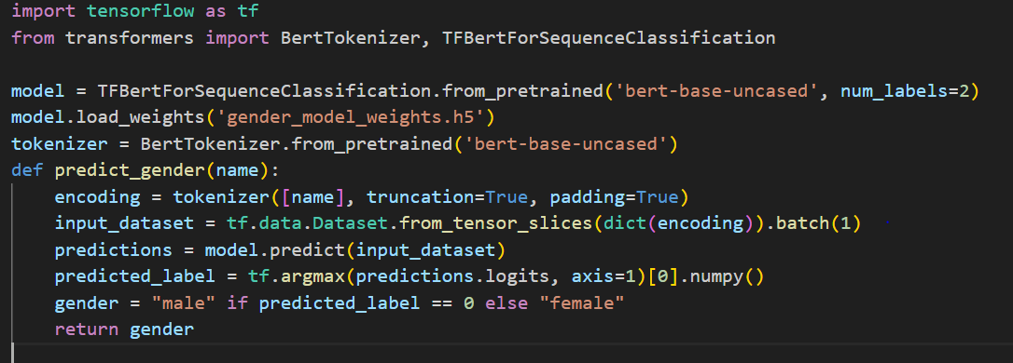

* **Social Network**

Then i build a **Social Network** by getting **IP** addresses and using **neo4j** data base in my **Bruno Bot**

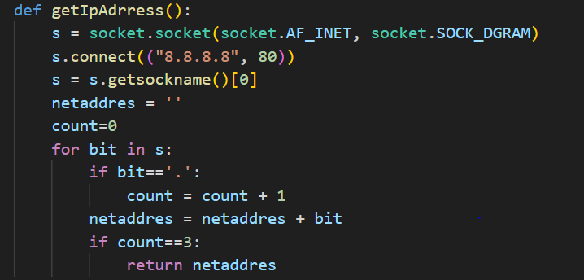

* **Web scrapping and Wordnet**

Then I used web scrapping in my chat Bot to get responses from the web. Web scraping is the process of extracting data from websites. I scrap Wikipedia to enable my bot to get answer from Wikipedia and WordNet is a lexical database and a widely used resource in natural language processing.

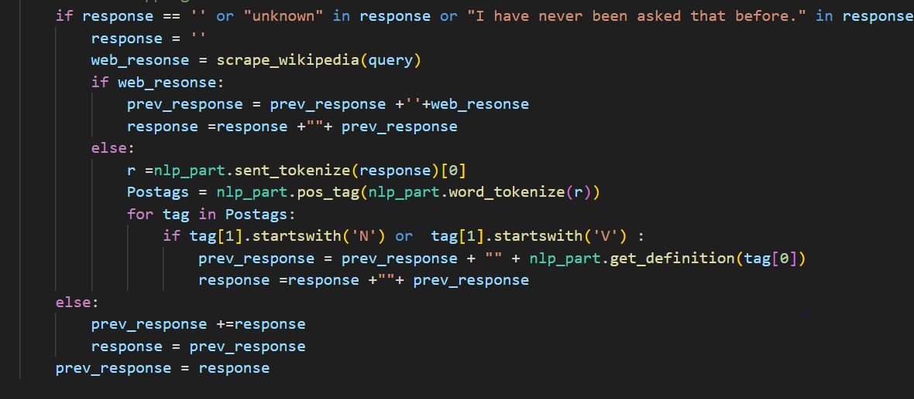

* **Prolog**

Then I implemented prolog in my chatbot to build relationship between entities.

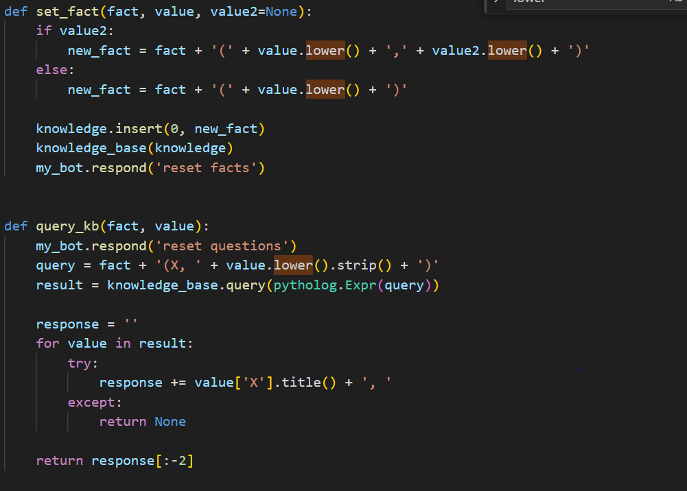

* **Episodic memory**

